Streetscape Leonia 2013 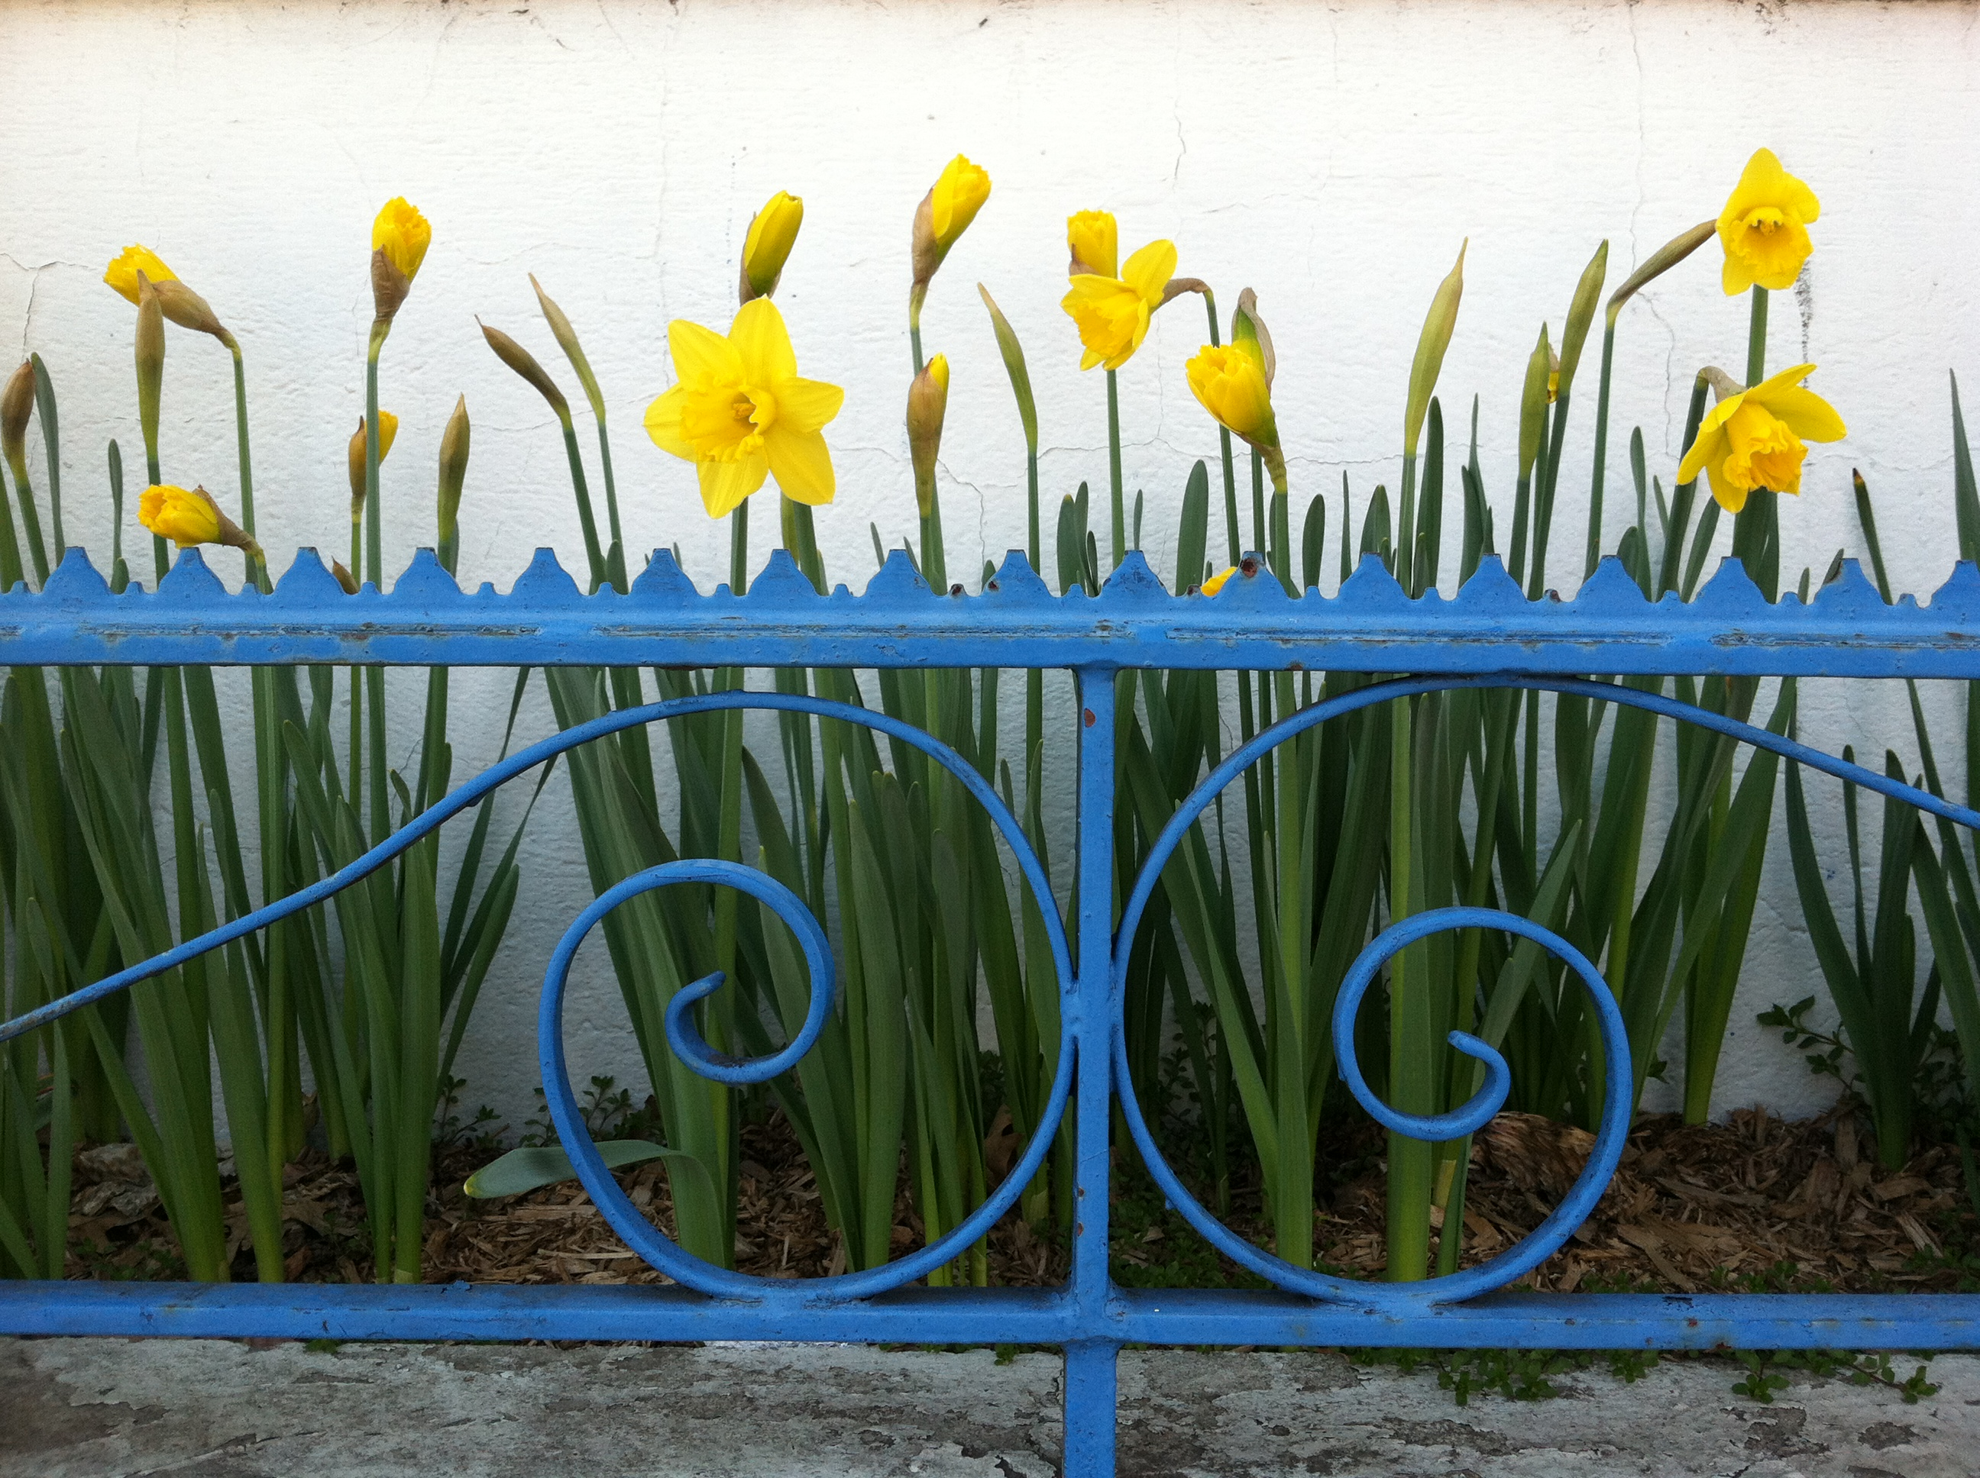
On behalf of the Leonia Transportation Committee, a Mayor Advisory Committee, you are cordially invited to participate in Streetscape Leonia 2013. Last year this successful initiative brought together representation from our community including residents, businesses and community groups. Volunteers are needed again to beautify Leonia’s public spaces by adopting one of the 16 build-in-stone planters along Broad Avenue and those in the Elm Street Parking Lot.
Modeled on Complete Streets concepts, streetscapes enhance our community spaces by making them more attractive and inviting. Environmental improvement is a vital part of promoting a sustainable community and economic regeneration. The area that looks good has a better chance to thrive – as well as being a nice place to live and work.
We are asking for volunteers (individuals, families, groups of friends, local businesses and community groups) to “plant the planters” in an informal arrangement and friendly co-operative atmosphere. What does this entail?
- Choose one of the numbered built-in planters along Broad Avenue (see attached listing) and confirm its availability.
- Commit to a) clean the site, b) plant and water the site and c) maintain the planter for 2013 season. Volunteers obtain their own supplies; there are no funds for this project. (Tree sites are not included in this program and are not to be planted).
- Where plants currently exist (other than weeds) volunteers are asked to leave these plantings in place and prune accordingly. Additional plantings are encouraged to improve overall appearance.
- Contact Ingrid Brennan, volunteer coordinator at Leoniatransportation@gmail.com to sign up or with any suggestions or questions.
We invite you to contribute to this initiative. There are no funds to apply for, no rewards, and this is not a competition. Every street should be beautiful. Thank you for consideration,
Ingrid Brennan, Chair, for the Leonia Transportation Committee
Leoniatransportation@gmail.com

